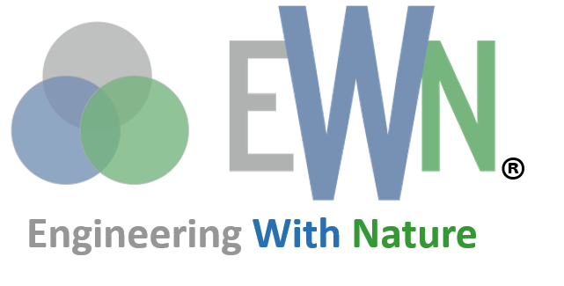

|  |  |  |
| --- | --- | --- |
| *Engineering With Nature® is the intentional alignment of natural and engineering processes to efficiently and sustainably deliver economic, environmental and social benefits through collaboration.* |  | *The Network for Engineering With Nature is a community of researchers, practitioners, and educators working together to advance Engineering With Nature®* |

Integrating Water Resources Infrastructure with Upland Management to Advance Nature-Based Solutions for Water Quantity and Quality

May 2023

|  |  |
| --- | --- |
| PRINCIPAL INVESTIGATORS | |
| UNIVERSITY PI POC  Name: Rebecca Muenich  Email: rmuenich@asu.edu  Phone Number: 480-965-1077  Department: SSEBE | ERDC PI POC  Name: Todd Steissberg  Email: Todd.E.Steissberg@usace.army.mil  Phone Number: 530-574-5572  Org. Code: U433D90 |
| OTHER TEAM MEMBERS | |
| Name 1: Rebecca Muenich  Name 3: Ting Liu  Name 5: Billy Johnson  Name 7: Lauren Melendez  Name 9: Jodi Ryder  Name 11: Selcuk Candan  Name 13: Todd Swannack | Name 2: Todd Steissberg  Name 4: Joanna Curran  Name 6: Isaac Mudge  Name 8: Billy Johnson  Name 10: Rose Shillito  Name 12: Amber Wutich |
| FUNDING REQUESTED ($K) | |
| UNIVERSITY: $555K  ERDC: $645K  PROJECT TOTAL: $1,200K | |

Project Background

## Project Abstract

Maintaining water quality while managing water resources, especially under extremes, is a difficult goal to achieve, since there are multiple drivers as well as potential control points throughout a given system. Beginning with the source areas in uplands [1], to the transport across the landscape [2] and into stream networks [3] and finally into reservoirs or other water infrastructure [4] – there are many points at which water quantity and quality can be influenced. Simultaneously, basins across the U.S. face extremes on both ends of the climate spectrum – flooding and drought – further emphasizing the importance of the role and management of existing water resources infrastructure like reservoirs [5], and the potential future role that natural or nature-based features (NNBF) may play. Despite the complexity of the basin systems across the U.S., management of upland landscapes (e.g., agricultural lands) or adjacent land areas to reservoirs, levees, and other water infrastructure systems is not typically aligned with the infrastructure management itself [6], let alone with the purpose of ensuring water quality alongside water quantity.

Beyond site-specific needs for NNBF to address both pillars of water management, a landscape-scale approach to implementation and coordination of NNBF and more traditional water resources infrastructure is needed to ensure efficiencies at scale. While the USACE has a strong focus on water control infrastructure, there is a missed opportunity to coordinate these with upland management to ensure that efforts made towards increasing NNBF are not negated. Quantifying and realizing the landscape-scale benefits to water quantity and quality in these integrated systems requires a modeling framework that can take complex site-specific interactions and upscale these disparate interactions on a system-wide and aggregated scale.

There are many land-use types across the basins that USACE and other government agencies manage, with agricultural lands representing the majority of non-government owned land in the U.S. These lands are often co-located with water resources infrastructure (e.g., levees and reservoirs; Figure 1), and are *actively* managed, often with practices similar to NNBF. Coordination and eventual integration of USACE, specifically its EWN activities, with upland agricultural management will help reduce system-wide inefficiencies and produce more synergistic outcomes for water quantity and quality.

|  |  |
| --- | --- |
| (a) | |
| (b) | (c) |
| Figure 1. Agricultural lands and water resources infrastructure in the Continental U.S. (a) Agricultural lands from USDA (green = pasture/range, orange = cropland). (b) Reservoir locations from USACE. (c) Levee locations from USACE. | |

Examples of these coordination activities include: 1) reservoir management with upland agricultural land management and 2) coordinating NNBF solutions (e.g., levee plantings and setbacks) with existing agricultural land management and conservation practice implementation. While integration of these two systems (landscape and surface waterbodies) is a long-term goal of this project, our primary objectives in the first three years are to assess the feasibility of this approach through nationwide data scoping and stakeholder engagement and to develop the modeling and data science tools and methods to inform best practices and enable USACE to locate and evaluate opportunities for NNBF across USACE-managed systems. This project addresses large knowledge gaps regarding how these systems work, e.g., whether in tandem or adversely, while identifying new strategies to advance where, when, and how these integrated landscapes can be better managed to mimic larger-scale, natural processes for a system-wide EWN approach that utilizes new and state-of-the art modeling and data science techniques.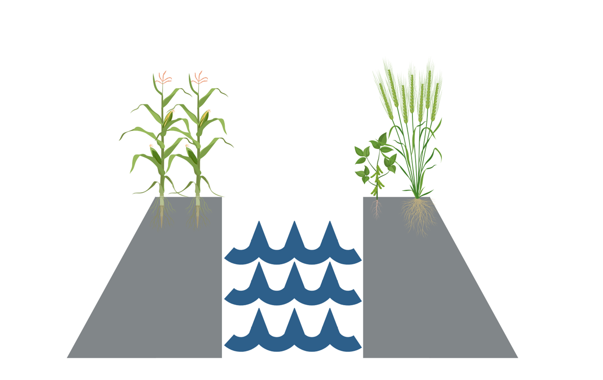

## Project Goal

The goal of this project is to explore and quantify how the coordinated management of upland landscapes with traditional or nature-based water resources infrastructure conservation practices can help to improve both water quantity and water quality outcomes at a system-scale. The outcomes of this project include nationwide site assessment of where manageable landscapes (e.g., agricultural lands) and water resources infrastructure are collocated and potentially already interacting (purposefully or not), an examination of feasibility and barriers to this coordinated management from a stakeholder perspective, and development of new methods, models, and tools that advance the understanding and coordination of these diverse systems as it relates to the use of NNBF in these complex systems.

## Statement of Need

Nature-based solutions utilize natural features and functions to protect, sustainably manage, and restore natural ecosystems to address societal challenges such as flooding, climate change, threats to human health, food and water security, and disaster risk, e.g., the strategic planting of vegetation to reduce flooding risk near rivers and in coastal areas. Because flow, water quality, and water temperature determine the health and dynamics of ecosystems, which in turn affect the flow and availability of water and nutrients through interception, storage, and evapotranspiration, integrated modeling of these parameters is essential for understanding the dynamics and functioning of ecosystems under various current and future conditions and stresses. Models can also identify key components that characterize ecosystems that remain dynamically stable over long periods, thus helping to lower operations and maintenance costs. Models can be especially useful in answering “what-if” scenarios such as: “How much volume and pollutant load reduction can be achieved by the placement of 10, 100, 1,000 constructed wetlands upstream of an overstressed reservoir?”

In the U.S., about three-fourths of the fresh water withdrawn each year comes from rivers, lakes, and reservoirs. The Clean Water Act requires every State to assign priorities for development of Total Maximum Daily Loads (TMDLs) based on the severity of the pollution and the sensitivity of the uses to be made of the waters, among other factors. TMDL analysis allows development of specific watershed protection plans designed to improve water quality of the impaired segments. In many cases nationwide, agricultural activities have been identified as a major source of point and nonpoint pollution. As a result, agricultural producers, conservation and environmental agencies, and water resources managers (in soil and water conservation districts, water supply companies, and river basin organizations) are under escalating economic and regulatory pressures to improve water quality. Yet many of the agricultural sources of pollutants and Constituents of Environmental Concern (CEC) originate in the “upstream watersheds” – that is, best understood by farmers, state agricultural agencies, USDA, and river authorities – while downstream water quality consequences accrue in lakes and reservoirs – best understood and managed by the USACE and affiliated lake and water reservoir managers. Thus, NNBF offers a unique link between managing water quantity and quality, as these features often help to improve both outcomes. Yet siting these features in complex systems where traditional water infrastructure projects co-exist with complex land management systems (such as agricultural uses) is difficult, given that most existing models do not model these three features (NNBF, agriculture, traditional water infrastructure) concurrently. This project addresses this disconnect by bringing together upstream landscape modelers and agriculture/local water system stakeholders with downstream USACE modelers, reservoir managers, and drinking water stakeholders, in addition to integrating NNBF to solve complex ecosystem challenges associated with shifting land use patterns and changing climate conditions.

## Problem or Opportunity

Nature-based solutions for infrastructure managed by the USACE and other entities exist, as do nature-based solutions for agricultural land management. These two systems typically operate asynchronously [7], potentially leading to worse outcomes for water quantity and quality, even when nature-based solutions are used. By integrating the management of these two disparately managed yet connected systems, we can work to advance both goals while simultaneously meeting water resources needs. This project will help to fill this important research gap by creating modeling and data science tools and methods that can work in these complex integrated systems. This project also aims to quantify impacts of the current lack of coordination of these efforts, which will benefit future management decisions.

## Project Value Statement

This project will deliver new data, tools, and applied methods for integrating upland management with water resources infrastructure management, including NNBF. The project team will present new information on the benefits of coordination and the potential negative consequences of no coordination between upland management and water resources infrastructure management on both water quantity and quality outcomes. We will achieve our objectives through a combination of data science with water resources modeling and management. Our findings will provide a roadmap of possibilities for this integration in the U.S. It is likely that the intentional integration of these two systems will also reduce overall inefficiencies with respect to environmental outcomes and infrastructure investment.

## How Does the Project Align with the EWN Program

At a high level, this project helps to identify and inform watershed-wide management strategies for NNBF implementation and traditional water resources infrastructure management, such that the overall system can better mimic large scale natural processes (and nature-based feature in and of itself). At a more granular level, this project will inform implementation and eventual coordination of NNBF in highly managed systems.

## How Does the Project Satisfy EWN Elements

|  |  |
| --- | --- |
|  | Leverage Natural Processes |
| This project will leverage natural processes by working with nature-based solutions on upland (agricultural) lands and nature-based solutions for existing infrastructure (e.g., planted levees, reservoir release schedules that prevent harmful algal blooms). We will also specifically focus on the synchronous management of these two systems which represents a reconnection of natural processes among upland, network, and downstream systems. | | |
|  | Produce Efficiencies |
| The disjointed management of upland systems and water resources infrastructure is likely contributing to large inefficiencies across the systems, especially when it comes to implementing newer NNBFs. Our project will work to identify and quantify these inefficiencies, as well as where and how they can be managed to produce more synergistic outcomes. Leveraging data science methods, integrating existing modeling frameworks, and working with stakeholders, the knowledge and tools developed for this project will be transferable across larger scales to expand EWN. | | |
|  | Broaden Benefits |
| This project directly links water infrastructure systems with contributing area management, identifying solutions that improve water resource management for water quantity and quality, while ensuring that similar efforts occurring within the upland systems are synergistic rather than counterproductive. There will also be benefits beyond the environmental outcomes, in terms of identifying opportunities for more synergies among federal spending across multiple (often siloed) domains. | | |
|  | Collaboration |
| This project will work across a wide variety of projects within the UASCE and ERDC system, from modeling studies to applied implementations of nature-based solutions. We are connecting to ERDC’s Coastal and Hydraulics Laboratory (CHL) – Rivers and Estuaries Engineering Branch (Rose Shillito), working on the connection between soil health and water quality and ERDC’s Environmental Laboratory (EL) – Water Quality and Contaminant Modeling Branch and team (Todd Steissberg and Jodi Ryder (EL), Isaac Mudge (MVN), and Billy Johnson (LimnoTech)), working on how reservoir management influences harmful algal blooms and reservoir water quality and developing a coupled SWAT-CE-QUAL-W2 model to better simulate these connected systems. | | |

## Objectives

This project will achieve its goals through five primary objectives:

1. Identify the potential for integrated management of upland areas and traditional water resources infrastructure (e.g., reservoirs, levees) across the U.S.
2. Select and model at least one of these systems at the watershed-scale, based on data scoping and stakeholder preferences from objective 1.
3. Implement, test, and monitor the performance of at least one nature-based solution in the selected system.
4. Develop methods to transfer learning and emulation modeling techniques to simulate and understand processes driving and controlling water quantity and quality in these integrated systems.
   1. Apply the models, methods, and data from objectives 1-4 to demonstrate the applicability of this integrated system management in basins across the U.S.

# Project Objectives and Outcomes

## Technical Approach

The main approach for this work is outlined in Figure 2. We will begin with a large data scoping process that involves synthesis and exploratory data analysis of existing data, concurrently with the collection and analysis of stakeholder perceptions of integrating agricultural land management with water resources infrastructure management. Data collection efforts will focus on data that informs or is related to the management of agricultural systems or water resources infrastructure (Table 1). Stakeholder data will be collected through a participatory modeling approach and stakeholder workshop near the close of year 1. Data from these two activities will be used to inform research questions regarding where collective management would be most useful and under what circumstances, which will help inform site selection for future modeling, implantation, and analysis.

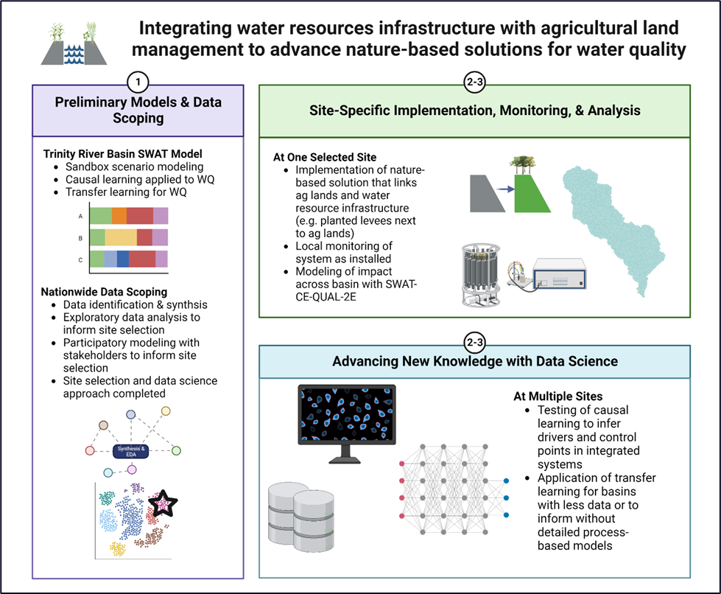

Figure 2. Overall project approach in years 1-3 (circles).

|  |  |  |
| --- | --- | --- |
| Table 1. Examples of data to be incorporated and synthesized for EDA and site selection activities (not exhaustive). | | |
| Data | Source | Reason for Inclusion |
| Agricultural lands | USDA Cropland Data Layer | Identifies location and types of agricultural lands in U.S. |
| Reservoirs & dams | National Inventory of Dams | Identifies location of dams and reservoirs across U.S., including structure, purpose, and owner information |
| Levees | National levee database | Identifies location and length of levees across the U.S., including details on benefits and risks |
| Water quality | National Water Quality Portal | Helps to inform issues specific to water quality across the U.S. |

Simultaneously, we will use an existing watershed model developed for the Trinity River Basin in Texas to explore collective/collaborative management of agroecological infrastructure and built water resources infrastructure. We will compare agroecological interventions and timing (e.g., changes in crop rotations, addition of cover crops, tillage, implementation of filter strips, and wetlands) with traditional water resources infrastructure management (e.g., release timing, hedging, dredging of reservoirs, planting vs. not planting levees adjacent to agricultural lands, increasing levee setbacks) to evaluate simulated water quality and quantity sensitivity to each action. We will then focus on running hypothetical scenarios to identify when and where within the watershed a collective management approach would be advantageous. This kind of scenario simulation is common practice for watershed models and can help to inform the larger scoping and site selection process.

Activities in years 2 and 3 will focus on expanding our understanding of these integrated systems in more detail through two major activities: The first develops an integrated SWAT-CE-QUAL-W2 model of a site selected from the data scoping, while simultaneously implementing a planted levee system (or other NNBF) in the same watershed [8, 9]. See Appendix C for more details on models used. This combined model-implementation-monitoring approach will provide real-time understanding of the effectiveness of one example of this integration at a local scale (implementation + monitoring) and determine the potential impacts of this practice at the basin scale and under different scenarios (detailed modeling).

The second major activity in years 2 and 3 will focus on developing transfer learning and emulation techniques using the data scoping and process-based models for two purposes: (1) understanding the drivers and controls of water quality across basins in the U.S. that have the potential to benefit from integrated management and (2) estimating the benefits of collective management of these systems in areas where data is sparser.

By the end of year 3, we expect to have key insights into the following:

1. Where, when, and how the integration of upland (agricultural) management and water resources infrastructure management can benefit water quantity and quality while still supporting USACE water management goals.
2. Drivers and controls of water quantity and quality across systems in the U.S. that could benefit from the integrated management approach.
3. How effective process-based modeling tools (e.g., new integration of SWAT-CE-QUAL-W2) can be at providing a simulation of integrated management solutions at local and basin scales.
4. The impact of at least one nature-based solution that exemplifies the integration of the two systems through both a monitoring and modeling effort.

## Collaboration

The University and ERDC teams are naturally complementary and synergistic: The ASU team brings expertise in watershed modeling and management along with new approaches for the use of machine learning to the collaboration, while the ERDC team brings extensive knowledge and experience in modeling and management of water resources infrastructure. Both partners understand how management influences water quality outcomes like harmful algal blooms, knowledge needed for protecting our water resources. The ERDC team also brings expertise in sediment and pollutant transport to the team, which further improves our ability to assess drivers of water quality impacts in these complex and dynamic systems.

ERDC will participate in this project by providing technical review, data, and analysis advice, such that data scoping, modeling, and data science activities are aligned with USACE strategic, tactical, and operational goals. ERDC will also work closely with the ASU team on site selection based on data scoping and stakeholder engagement. Narrowing down potentially hundreds of candidate watersheds to one predicted to generate good engagement from the USACE District, as well as enough local data to advance the modeling and data science initiatives, will be a key role for ERDC researchers.

ASU will also bring strong expertise in data science and participatory modeling (detailed in other PMPs) to help strengthen the methods in these domains.

The project as proposed already incorporates collaboration with a USACE District (Joanna Curran, Seattle District) in the implementation, monitoring, and modeling of a planted levee adjacent to an agricultural system. Dr. Curran has an existing project to assess the vegetation type in planted levee systems and understanding how current levee management can adapt to this EWN approach.

In addition, our model implementation in the Trinity will be in collaboration with the Trinity River Authority which works closely with USACE District (Fort Worth District) and other ERDC collaborators. The ERDC collaborators also have a working relationship with the USDA and researchers at Texas A&M with similar interests in integrating water infrastructure with agricultural ecosystems management. Leveraging these many partnerships will help our project advance faster.

## Activities, Deliverables, POCs, and Schedule

Rebecca Muenich will lead the data scoping activities in year one, in close collaboration with Selcuk Candan (see data science PMP), Todd Steissberg, Rose Shillito, and Joanna Curran. Within this larger scoping activity, a graduate student mentored by Rebecca Muenich will help identify data to be used in scoping (October 2022 - January 2023), synthesizing, and cleaning the data to prepare a database (January 2023 - May 2023) and working in collaboration with the data science team on exploratory data analysis (May 2023 - August 2023). Simultaneously, Ting Liu will be leading the completion of preliminary and exploratory SWAT modeling to explore theoretical interconnections between agricultural land management, reservoir management, and water quality as a model scoping activity (August 2022 - December 2022). Ting Liu will also work collaboratively with Selcuk Candan’s data science team to complete preliminary investigations into how causal learning can be applied to understand drivers of water quality in these complex systems (August 2022 - July 2023). By the end of year one, Amber Wutich will be mentoring postdoctoral scholars as they plan and host a workshop with key stakeholders regarding barriers, benefits, and opportunities to the integrated management of these two systems (June 2023 - December 2023). The aforementioned activities will all be used in conjunction with full-team discussions to identify a watershed (site) to work with in subsequent years (August 2023 - December 2023).

In year two, we have defined two simultaneous tracks of work: process-based modeling and data science for understanding the drivers of water quality in these systems as well as identifying the role and impact of NNBF in creating synergies across these systems. Todd Steissberg will lead the process-based modeling aspects of this work in close collaboration with Rebecca Muenich (and her PhD student), Ting Liu, Jodi Ryder, Isaac Mudge, Lauren Melendez, and Billy Johnson. The team will work together to develop and apply a calibrated SWAT-CE-QUAL-W2 model for the selected watershed (August 2023 - June 2024). Generally, the ASU team will focus on the SWAT aspects of the model, while the ERDC team will focus on the CE-QUAL-W2 aspects of this model. The model development and testing are likely to begin before site selection in order to begin work as soon as a site is confirmed. Joanna Curran will lead the implementation of a monitoring program for a planted levee demonstration in the chosen watershed, in close collaboration with Rebecca Muenich and her PhD Student (January 2024 - June 2024). The system will be monitored over the course of the project (June 2024 - July 2025). The data will be analyzed and used in the SWAT-CE-QUAL-W2 model calibration (June 2024 - July 2025). Local participatory modeling with stakeholders involved in the watershed site will be led by Amber Wutich (April 2024 - July 2025).

While the process-based modeling team focuses on modeling a specific watershed, a separate team led by Selcuk Candan (see data science PMP) in close collaboration with Rebecca Muenich, Ting Liu, Rose Shillito, and Todd Steissberg. Within this task Selcuck Candan (along with PhD students and postdocs) will work closely with Ting Liu and Rose Shillito on using causal learning techniques with the data-scoping data to understand varying drivers of water quality in sites identified as having significant agricultural lands and water resource infrastructure (June 2024 - June 2025). A separate and concurrent task led by Selcuk Candan in collaboration with Rebecca Muenich and Todd Steissberg will test and demonstrate the use of transfer or emulation methods to model sites as opposed to setting up a SWAT-CE-QUAL-W2 model (June 2024 - July 2025). This work will allow comparison of these two methods and generate recommendations for future work. In the last year of the project, Rebecca Muenich will lead the full team to summarize scenarios and findings from the modeling, monitoring, and data science activities to make final recommendations for strategies in these integrated systems, as well as outlining next steps and future areas of research (January 2025 - July 2025).

## Communication and Technology Transfer Plan

Initially, our outcomes will be focused on communicating new research results with the academic and research community through conference publications, journal articles, and conference presentations. Major results and findings will be packaged into continuing credit courses for NEWN, EWN fact sheets, and podcasts. Progress will also be updated monthly on ASU’s EWN website blog, highlighting collaborations and ongoing activities. When relevant, policy white papers will be developed and distributed.

The stakeholder workshop planned for the end of year one will help determine major barriers as well as opportunities related to the integration of agricultural land management and water resources infrastructure. The outcomes of this workshop will be documented in a policy brief to advance the longer-term goal of more integrated activities at the federal, state, and local levels. Similar outcomes will be developed from the local stakeholder participatory modeling that occurs in year 2 at the modeled and monitored site.

Wherever possible, data and modeling tools will be made publicly available for further use. This practice is common among both the ASU and ERDC collaborators (see: <https://github.com/EnvironmentalSystems/CE-QUAL-W2>)

## Expected Benefits and Impact

While the USACE is not tasked with managing working agricultural lands or other upland systems, activities that occur on these lands impact activities undertaken and prioritized by USACE. This project will not only advance the understanding of where and when these disconnections are most likely affecting outcomes, but it will also work to identify and develop methods and tools to better understand and address this concern. Ideally, modeling outcomes will also be used to suggest ways in which NNBF and nature-based management strategies can work in tandem with upland management to secure better water quantity and quality outcomes while still effectively managing water resources.

## Cited References

[1] Chaplin-Kramer, R., Hamel, P., Sharp, R., Kowal, V., Wolny, S., Sim, S., & Mueller, C. (2016). Landscape configuration is the primary driver of impacts on water quality associated with agricultural expansion. *Environmental Research Letters*, *11*(7), 074012.

[2] Mander, Ü., Kull, A., Kuusemets, V., & Tamm, T. (2000). Nutrient runoff dynamics in a rural catchment: influence of land-use changes, climatic fluctuations and ecotechnological measures. *Ecological Engineering*, *14*(4), 405-417.

[3] Stieglitz, M., Shaman, J., McNamara, J., Engel, V., Shanley, J., & Kling, G. W. (2003). An approach to understanding hydrologic connectivity on the hillslope and the implications for nutrient transport. *Global biogeochemical cycles*, *17*(4).

[4] Kerachian, R., & Karamouz, M. (2006). Optimal reservoir operation considering the water quality issues: A stochastic conflict resolution approach. *Water Resources Research*, *42*(12).

[5] Zhou, Q., Leng, G., & Peng, J. (2018). Recent changes in the occurrences and damages of floods and droughts in the United States. *Water*, *10*(9), 1109.

[6] Gleick, P. H. (2016). Water strategies for the next administration. *Science*, *354*(6312), 555-556.

[7] Young, O. R., Guttman, D., Qi, Y., Bachus, K., Belis, D., Cheng, H., ... & Zhu, X. (2015). Institutionalized governance processes: Comparing environmental problem solving in China and the United States. *Global Environmental Change*, *31*, 163-173.

[8] Arnold, J. G., Moriasi, D. N., Gassman, P. W., Abbaspour, K. C., White, M. J., Srinivasan, R., ... & Jha, M. K. (2012). SWAT: Model use, calibration, and validation. *Transactions of the ASABE*, *55*(4), 1491-1508.

[9] Wells, S. A., Cole, T. M., Zhang, Z., and Steissberg, T. E. (2022). CE-QUAL-W2: A Two-Dimensional, Laterally Averaged, Hydrodynamic and Water Quality Model, Version 4.5.

# Schedule and Funding

Identify the proposed budget for the project for the current and future fiscal years until project completion. The budget should include all costs (labor, burdens, travel, purchases, etc.).

Show the costs for the University and for ERDC separately since these costs are covered by different funding streams.

## Overall Requested Funding

Use the table below to show the requested funding for the current and future fiscal years until project completion.

Show the requested University and ERDC funding separately since these costs are covered by different funding streams.

|  |  |  |  |  |  |
| --- | --- | --- | --- | --- | --- |
| UNIVERSITY FUNDING | | | | | |
| Fiscal Year | Q1 ($K) | Q2 ($K) | Q3 ($K) | Q4 ($K) | TOTAL ($K) |
| FY23 | $45K | $45K | $45K | $45K | $180K |
| FY24 | $45K | $45K | $45K | $45K | $180K |
| FY25 | $45K | $45K | $45K | $45K | $180K |
| Total Budget: | | | | | $540K |

|  |  |  |  |  |  |
| --- | --- | --- | --- | --- | --- |
| ERDC FUNDING | | | | | |
| Fiscal Year | Q1 ($K) | Q2 ($K) | Q3 ($K) | Q4 ($K) | TOTAL ($K) |
| FY23 | $0K | $0K | $105K | $110K | $215K |
| FY24 | $50K | $55K | $55K | $55K | $215K |
| FY25 | $50K | $55K | $55K | $55K | $215K |
| Total Budget: | | | | | $645K |

## Requested Funding by Cost Type

Indicate the funding requested for labor, subcontractors, travel, equipment, and any other costs.

Show the requested University and ERDC funding separately since these costs are covered by different funding streams.

|  |  |  |  |  |
| --- | --- | --- | --- | --- |
| UNIVERSITY FUNDING | | | | |
| COST TYPE | FY23 ($K) | FY24 ($K) | FY25 ($K) | TOTAL ($K) |
| LABOR COSTS |  |  |  |  |
| Rebecca Muenich (faculty; ASU) | $15K | $15K | $15K | $45K |
| Ting Liu (postdoc; ASU) | $80K | $80K | $80K | $240K |
| Danna Villarreal (Ph.D. student, ASU) | $70K | $70K | $70K | $210K |
| OTHER COSTS |  |  |  |  |
|  |  |  |  |  |
| Travel | $20K | $20K | $20K | $60K |
| TOTAL | $185K | $185K | $185K | $555K |

| ERDC FUNDING | | | | |
| --- | --- | --- | --- | --- |
| COST TYPE | FY23 ($K) | FY24 ($K) | FY25 ($K) | TOTAL ($K) |
| LABOR COSTS |  |  |  |  |
| Todd Steissberg | $20K | $20K | $20K | $60K |
| Joanna Curran | $5K | $25K | $25K | $55K |
| Isaac Mudge | $15K | $15K | $5K | $35K |
| Lora Johnson | $15K | $10K | $10K | $35K |
| Lauren Melendez | $8K | $5K | $8K | $21K |
| Jodi Ryder | $10K | $10K | $10K | $30K |
| Rose Shillito | $20K | $15K | $15K | $50K |
| Todd Swannack | $5K | $5K | $5K | $15K |
| Total Labor | $98K | $105K | $98K | $301K |
| OTHER COSTS | $2K | $2K | $2K | $6K |
| Subcontractor | $85K | $78K | $85K | $248K |
| Travel | $30K | $30K | $30K | $90K |
| TOTAL | $215K | $215K | $215K | $645K |

## Requested Funding for Project Activities

The budget requested in this PMP does not include budgets from the cross-cutting PMPs of data science and participatory modeling. So here we describe only the budgets for data scoping, analysis, and modeling activities associated with this PMP.

Preliminary modeling and data science methods will cost $138.2K. Data scoping activities, including data identification, synthesis, analysis, and site selection, will cost $173.1K. Site selection and methods scoping for years 2 and 3 will cost $59.3K. Site-specific watershed modeling activities will cost $236.3K. NNBF site monitoring will cost $196.8K. Testing and implementing advanced machine learning methods in new sites or for causal learning will cost $135.0K Scenario analysis to inform systems management will cost $181.4K.

Costs for developing scientific articles, white papers, blog posts, and other communication products are included in the related activity budgets. Travel costs were split evenly across each activity.

## Cost-Sharing or In-Kind Contributions

While we do not currently have any cost-sharing or in-kind contributions, there is the potential to leverage existing collaborations between ERDC and the USDA on the SWAT-CE-QUAL-W2 model development, which may be considered as in-kind if funded in the future.

The project team will also leverage this collaboration to pursue additional funding opportunities together through agencies such as the USDA and NSF.

## Risk Management

Workflow: We have purposely included modeling, data synthesis, and new data collection throughout the project to provide opportunities to work both independently and synergistically as needed. While the activities are all connected to each other, there is little direct dependency which could potentially delay the timeline. For example, while some tasks in years two and three depend on the data scoping in year one, the Trinity River modeling can provide some outcomes and data to work with in the case that the data scoping results are delayed.

USACE Receptiveness: Another potential issue that could arise is that sites we think may have the best chance for integrated system management (through scoping) may not have willing district leads to help champion this integration. However, we are already working with an existing USACE-led project, so we do not anticipate this to be a major issue. Also, given the prevalence of levees and reservoirs in agricultural basins, we expect there to be many sites to choose from for our implementation purposes.

Application to NNBF: We are proposing to work with existing USACE projects that will install planted levees, such that we can monitor and model the system in our watershed-site based work. If we are unable to coordinate timing or otherwise with this existing project, we have two alternatives already identified: (1) find another USACE or EWN team focused on implementation of a NNBF in one of our potential working sites to work with. Funds will be reallocated for monitoring and modeling of that NNBF; (2) work with teams studying the impact of reservoir management as a nature-based solution and use that for our NNBF. Funds will be reallocated for monitoring the effectiveness of changes in strategies.

# Project Delivery Team Members

## Principle Investigator Point of Contact

|  |  |
| --- | --- |
| University POC | ERDC POC |
| Name: Rebecca Muenich | Name: Todd Steissberg |
| Title: Assistant Professor | Title: Research Environmental Engineer |
| Email: rmuenich@asu.edu | Email: Todd.E.Steissberg@usace.army.mil |
| Phone: 480-965-1077 | Phone: 530-574-5572 |
| Department: SEBE | Org. Code: U433D90 |

## Project Delivery Team

|  |  |  |
| --- | --- | --- |
| PDT Member | Institution | Project Role |
| Rebecca Muenich, rmuenich@asu.edu, 480-965-1077 | ASU | University Lead and project Co-lead. Will mentor graduate students and postdocs to perform data scoping and modeling tasks. Will plan and organize project meetings |
| Todd Steissberg, Todd.E.Steissberg@uasce.army.mil, 530-574-5572 | ERDC | ERDC Lead and project Co-lead. Will supervise ERDC staff to collaborate on data scoping task and lead model integration application tasks. |
| Selcuk Candan, selcuck.candan@asu.edu | ASU | Data science PMP lead; will mentor scholars on completing the data science focused tasks. |
| Amber Wutich, Amber.Wutich@asu.edu | ASU | Participatory modeling PMP lead; will mentor postdocs on completing outlined stakeholder engagement activities |
| Jodi Ryder, Jodi.L.Ryder@erdc.dren.mil | ERDC | ERDC collaborator working with Todd on advancing the SWAT-CE-QUAL-W2 model |
| Rose Shillito, Rose.M.Shillito@usace.army.mil | ERDC | ERDC collaborator that will help provide guidance and insight for the data scoping and data science for understanding drivers activities |
| Billy Johnson, [Billy.E.Johnson@erdc.dren.mil](mailto:Billy.E.Johnson@erdc.dren.mil)  601-415-6299 | ERDC – LimnoTech Inc. | ERDC contractor working with Todd on advancing the SWAT-CE-QUAL-W2 model |
| Ting Liu, tliu154@asu.edu | ASU | ASU postdoctoral scholar who will work with Todd on advancing the SWAT-CE-QUAL-W2 model and help coordinate the data science activities with Selcuk |
| Isaac Mudge, Isaac.J.Mudge@usace.army.mil | ERDC | Will work with ASU graduate student on the development and application of the SWAT-CE-QUAL-W2 model. |
| Lora Johnson, Lora.L.Johnson@usace.army.mil | ERDC | Will develop software to link SWAT output data with CE-QUAL-W2 and will evaluate software for security compliance for deployment for USACE |
| Lauren Melendez, [Lauren.Melendez@usace.army.mil](mailto:Lauren.Melendez@usace.army.mil) | ERDC | Will coordinate EWN communications for ERDC team |
| Monica Williams, Monica.S.Williams@asu.edu, 602-543-5075 | ASU | Communications lead |
| Tara Seaton, Tara.Seaton@asu.edu, 480-965-6804 | ASU | Financial Lead |

# Appendix A: Summary Table of Activities, Deliverables, Communication Plan, and Budget

|  |  |  |  |  |  |  |  |
| --- | --- | --- | --- | --- | --- | --- | --- |
| Activity | Deliverable | Communication/Technical Transfer Plan | Lead POC | Anticipated Start Date (Month and Year) | Anticipated End Date (Month and Year) | Estimated Budget for Completion | Percent Completed |
| Exploratory modeling analysis of combined ag lands + reservoir management | Multiple SWAT scenarios exploring links and impacts on water quality | Journal publication, webinar, EWN website content | Liu | 08-2022 | 12-2022 | ASU: $46.9K  ERDC:  $25.0K | 50% |
| Exploratory analysis of causal learning to understand water quality outcomes | Causal learning maps and analysis | Journal publication, webinar, EWN website content | Candan | 08-2022 | 07-2023 | ASU: $36.2K  ERDC:  $30.0K  Other funds in Data Science PMP | 50% |
| Identify data to be used in large scoping activity | Comprehensive list of data, sources, and metadata | N/A- internal outcome | Muenich | 10-2022 | 01-2023 | ASU: $26.3K  ERDC:  $25.0K | 0% |
| Synthesis and transformation of data for scoping | Database of cleaned, transformed, and ready to use data | N/A – internal outcome | Muenich | 02-2023 | 05-2023 | ASU: $46.3K  ERDC:  $20.0K | 0% |
| Exploratory data analysis of scoping data | Data results to answer initial questions about the feasibility of integrating ag land management with gray infrastructure management | Journal publication, EWN website content, webinar | Muenich | 06-2023 | 08-2023 | ASU: $35.5K  ERDC:  $20.0K | 0% |
| Scoping study with stakeholders via a participatory stakeholder meeting | Perceptions and barriers to integrating ag land management with gray infrastructure management | White paper, webinar, EWN Website content | Wutich | 06-2023 | 12-2023 | Other funds in Participatory Modeling PMP | 0% |
| Defining scope of machine learning transfer and causal learning work | Plan to use data scoping effort to identify specific research directions for transfer learning and causal learning | N/A – internal outcome | Candan | 08-2023 | 12-2023 | ASU: $14.5K  ERDC:  $10.0K  Other funds in Data Science PMP | 0% |
| Site selection for model and demonstration studies | Watershed in the U.S. to be used for demo and SWAT-CE-QUAL-2E model development | N/A – internal outcome | Steissberg | 08-2023 | 12-2023 | ASU: $17.4K  ERDC:  $15.0K | 0% |
| Participatory modeling with stakeholders at specific site | Local stakeholder perspectives on barriers and opportunities for watershed scale coordination of NNBF and solutions. | White paper, journal article, EWN website content | Wutich | 4-2024 | 7-2025 | Other funds in Participatory Modeling PMP | 0% |
| Installation of levee demo site and monitoring program | Demo site with monitoring setup | Blog post, EWN website content, monitoring data with its own DOI | Curran | 01-2024 | 06-2024 | ASU: $13.4K  ERDC:  $75.0K | 0% |
| Model development and linkage with SWAT for watershed with demo site | Calibrated SWAT-CE-QUAL-W2 model for demo site’s watershed | Journal publication, webinar, EWN website content | Steissberg | 08-2023 | 06-2024 | ASU: $86.3K  ERDC:  $150.0K | 0% |
| Analysis of demonstration site data | Estimates of levee effectiveness at local level based on 1-2 years of monitoring data | Journal publication, webinar, EWN website content | Muenich | 06-2024 | 07-2025 | ASU: $48.4K  ERDC:  $60.0K | 0% |
| Identification of drivers and controls of water quality in integrated systems using causal learning techniques | Identified drivers for various integrated systems across the U.S. | Journal publication, webinar, EWN website content | Shillito | 05-2023 | 06-2025 | ASU: $32.3K  ERDC:  $50.0K  Other funds in Data Science PMP | 0% |
| Demonstration of transfer or emulation methods to model data-poor integrated systems | Assessment of transfer learning and emulation methods for modeling data-poor systems | Journal publication, webinar, EWN website content | Candan | 06-2024 | 07-2025 | ASU: $70K  ERDC:  $65.0K  Other funds in Data Science PMP | 0% |
| Scenario analysis within existing models to further demonstrate potential water quality improvements from integrated management | List of potential strategies and approaches to improve water quality through cohesive systems management based on cumulative work | White paper, webinar, EWN website content, journal article | Muenich | 01-2025 | 07-2025 | ASU: $81.4K  ERDC:  $100.0K | 0% |
| TOTAL BUDGET: | | | | | | $1,200K | |

# Appendix B: PDT Biographies

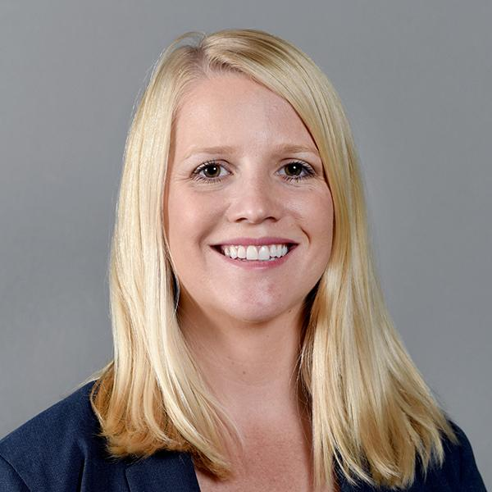

Rebecca Muenich (Ph.D.) is an Assistant Professor in the School of Sustainable Engineering and the Built Environment at Arizona State University. Dr. Muenich holds a B.S. in Biological Engineering from the University of Arkansas in 2009, an M.S. and Ph.D. in Agricultural & Biological Engineering from Purdue University in 2011 and 2015, respectively, and completed a postdoctoral position at the Graham Sustainability Institute at the University of Michigan from 2015- 2017. She joined Arizona State University as an Assistant Professor in the School of Sustainable Engineering and the Built Environment in the Fall of 2017. She has published 41 peer-reviewed articles and her work has been presented over 70 times at national and international conferences, including 5 invited presentations. She was a recipient of the ASABE Robert E. Stewart Engineering and Humanities Award from ASABE in 2011, named a New Face of ASABE in 2020, inducted into the Arkansas Academy of Agricultural and Biological Engineering in 2020, received an Outstanding Faculty Mentor award from the ASU Faculty Women’s Association in 2021, and was awarded an Early Career Award from the University of Arkansas College of Engineering in 2022.

Her research focuses on integrating geospatial sciences and watershed modeling to evaluate trade-offs in land and water resources management, especially for water quality outcomes. She has 10+ years of environmental and watershed modeling experience, with a focus on managing agroecosystems and providing policy-relevant solutions. Her work has been used by policymakers and regulators in the Midwest to inform domestic action plans to achieve nutrient load targets. She has also recently focused on analyzing environmental and water resources impacts of large-scale animal production in the US.

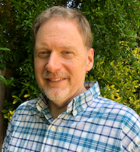

Todd Steissberg (Ph.D., PE) is a Research Environmental Engineer at the U.S. Army Engineer Research and Development Center's Environmental Laboratory (ERDC-EL). Dr. Steissberg leads a team at the U.S. Army Engineer Research and Development Center (ERDC) that develops and applies water quality and environmental systems models for rivers, reservoirs, and watersheds. The objective of his research is to provide interdisciplinary teams with the tools and methods needed to perform integrated watershed-scale environmental impact assessments, improve water quality management and real-time operations, and design and implement ecosystem restoration projects that incorporate natural and nature-based features (NNBF) to improve the health and resiliency of ecosystems and communities. Dr. Steissberg obtained his B.S. in Civil Engineering from Washington State University, where he researched air pollution chemistry and transport processes and aquatic ecosystem restoration. Dr. Steissberg obtained his M.S. and Ph.D. in Civil and Environmental Engineering from University of California, Davis, while serving as a NASA Earth System Science fellow at NASA/JPL, researching satellite-based remote sensing, physical limnology, and water quality. As a Postdoctoral Researcher at the Tahoe Environmental Research Center, John Muir Institute of the Environment, University of California, Davis between 2008 and 2010, he developed methods to characterize nearshore and offshore water quality and its spatial-temporal variability using satellite and field measurements. Dr. Steissberg lead development and application of water quality models and geospatial tools as a Senior Hydraulic Engineer at the U.S. Army Corps of Engineers' Hydrologic Engineering Center (USACE-HEC) between 2008 and 2019. In 2019, he transitioned to ERDC to continue his research and build a team of researchers to address complex issues in water quality and water resource modeling, ecosystem restoration, and environmental resiliency and adaptation of freshwater and coastal ecosystems, civil works infrastructure, and military installations under the threat of climate change. Dr. Steissberg is the lead developer of ERDC’s CE-QUAL-W2 model and the Corps Library for the Environmental Analysis and Restoration of Watersheds (ClearWater) and continues to lead water quality capability development for the HEC models (HEC-RAS, HEC-ResSim, and HEC-HMS).



Ting Liu (Ph.D.) is a Postdoctoral Research Scholar who joined ASU Environmental Engineering Dr. Rebecca Muenich’s research team at the beginning of 2021. His current research focuses on locating and tracking non-point source pollutants and their impact on river water qualities. Before joining ASU, he was on a one-year post-doc appointment with Purdue University researching industrial water use in the US. He finished a master’s degree in Civil Engineering and a Ph.D. degree in Environmental Engineering, both at Stevens Institute of Technology, Hoboken, NJ. His research interests mainly focus on water resources topics: water use, surface hydrology, machine learning in the application of water-environmental problems, water collection systems, the interaction between surface water and groundwater, and the transport of contaminants in both surface water and groundwater.

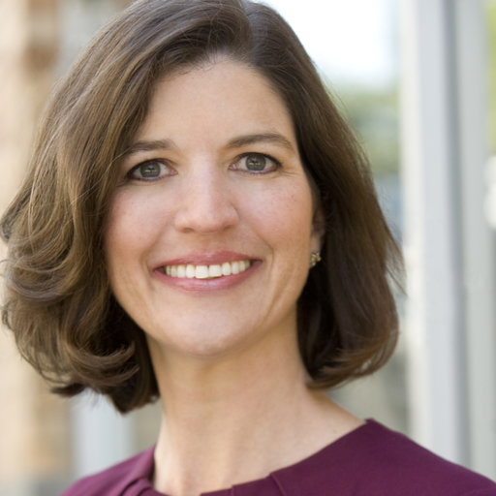

Joanna Crowe Curran (Ph.D., PE) is a geomorphic engineer with Indicator Engineering in Seattle, WA. She is an expert in sediment transport, fluvial geomorphology, and river engineering, and is the co-developer of the Wilcock-Crowe surface-based transport model. Dr. Curran has evaluated river mechanics and geomorphology across the nation, with particular emphasis in urbanizing watersheds. Dr. Curran has addressed sediment issues as they pertain to aquatic habitat, contaminant transport, reservoirs, and impacts river adjacent infrastructure. She has experience with low impact development, stormwater management practices, river restoration design, and dam removal. Dr. Curran earned her PhD in Environmental Engineering at The Johns Hopkins University under the supervision of Dr. Peter Wilcock. She was a tenured professor at the University of Virginia before moving to Seattle to join private consulting. Dr. Curran maintains an adjunct appointment in the Department of Civil and Environmental Engineering at the University of Tennessee and is active in ASCE EWRI as the chair of the stream restoration committee.

Billy E. Johnson (Ph.D., PE) is a Senior Scientist at LimnoTech with broad expertise in water resources, including successful leadership of projects involving the development and application of sediment, nutrient, contaminant, and riparian vegetation simulation modules for civil works and military projects. These modules have been integrated with a variety of U.S. Army Corps of Engineers (USACE) hydraulic and hydrologic modeling systems. He has over 35 years of experience as a research civil engineer, educator, and consultant for projects across the U.S. In addition, he has been involved in developing U.S. Army Installation Energy and Water Plans (IEWP), Flood Mapping and Mitigation Plans for Overseas DoD Installations in data-poor regions, and Low Impact Development (LID)/Nature-Based Features projects for DoD installations. Billy previously served as a senior researcher at the U.S. Army Engineer Research and Development Center (ERDC), Environmental Laboratory (EL). In addition to working for EL, he also worked for the ERDC Coastal and Hydraulics Laboratory (CHL), and the Memphis District USACE. He was an adjunct faculty member at Mississippi State University and served as an Associate Editor of the Journal for the American Water Resources Association (JAWRA). Billy currently resides and works in Vicksburg, Mississippi.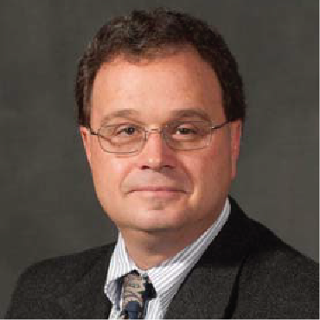



Isaac Mudge (E.I.T.) is a hydraulics engineer at US Army Corps of Engineers. Isaac works in ERDC’s Environmental Lab on developing and advancing CE-QUAL-W2 models. Isaac received a B.S. and MS in Environmental and Water Resources Engineering from Tufts University. Before working for USACE, Isaac interned at Shawmut Design and Construction, the National Wildlife Federation, and the Restore Mississippi Delta program.



Jodi Ryder (Ph.D.) is an interdisciplinary researcher specializing in geoenvironmental engineering at the U.S. Army Engineer Research and Development Center (ERDC). Her work requires the integration of geochemistry, hydrogeology, surface chemistry, and fluid mechanics to solve water quality and fate and transport problems from a process-based perspective.

Rose Shillito (Ph.D.) is a Research Physical Scientist with the CHL REEB lab. She has a Bachelor’s degree in Geography and Soils, and a Master’s degree in Hydrology and Water Resources, both from the University of Arizona in Tucson, AZ. Additionally, she had a Ph.D. in Geoscience from the University of Nevada, Las Vegas. Professionally, she has worked as a hydrologist for the Pima County Flood Control District in Tucson, AZ and as a hydrologist and soil scientist with the USDA-Agricultural Research Service in AZ, CO, and MD. Rose specializes in arid land processes, critical zone processes, wind and water erosion, infiltration, and runoff. Her current research focus concerns wildfire effects on soil and infiltration, subsequent effects on surface flow, erosion, flooding and debris flows, and the spatial extent and temporal persistence of post-wildfire effects.

Todd Swannack (Ph.D.) is a Research Biologist and the lead for the Integrated Ecological Modeling Team, which develops and applies coupled ecological and engineering models for the EWN initiative. His EWN-related research explores the roles of coupling ecological and physical processes to predict environmental response to EWN-related projects. In addition to his modeling research, he is involved in developing engineering guidance for the design and application of natural-based features (NNBF). He is also an adjunct faculty at the Department of Biology, Texas State University. His research interests include ecological modeling, ecosystem ecology, environmental science, population monitoring, and the restoration of oyster populations.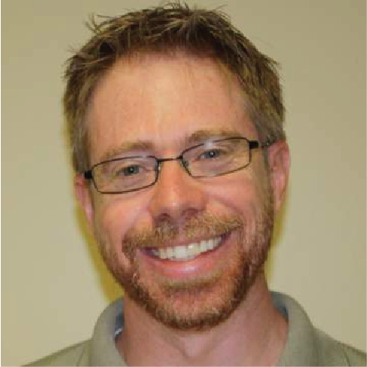

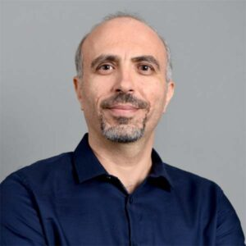

K. Selcuk Candan (Ph.D.) is a professor of computer science and engineering at the Arizona State University. He joined ASU in August 1997, after receiving his doctorate from the Computer Science Department at the University of Maryland at College Park. He has worked extensively on the integration and presentation of heterogeneous and distributed information and information sources. His research interests include multimedia and web data management. His current research projects include quality adaptive data processing and indexing for sensory data, distributed data management and Internet technologies for efficient dynamic content delivery, and adaptive information management for creating technologies helping blind individuals. His research projects are funded by the National Science Foundation, Department of Defense, and Department of Education (Rehabilitation Services Administration). He has published more than 80 articles in respected journals and conferences in related areas. He served in the organization and program committees of various international conferences. Most recently, he is an editorial board member of the Very Large Databases (VLDB) journal and the Journal of Multimedia.

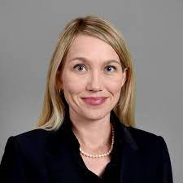

Amber Wutich (Ph.D.) is a President’s Professor of Anthropology and Director of the Center for Global Health at Arizona State University. Her two decades of community-based fieldwork are concerned with how inequitable and unjust resource institutions impact people’s well-being, especially under conditions of poverty. An expert on water insecurity and mental health, she directs the Global Ethnohydrology Study, a cross-cultural study of water knowledge and management. Wutich maintains longstanding ties in her field sites in Paraguay and Bolivia, and she manages a strategic alliance between la Universidad Nacional de Itapúa (Paraguay) and ASU. An ethnographer and methodologist, Wutich has authored 150+ peer-reviewed publications, co-authored 4 books, edits the journal Field Methods, and directs the NSF Cultural Anthropology Methods Program. Her teaching has been recognized with awards such as Carnegie CASE Arizona Professor of the Year. Wutich has raised over $44 million in research funds, as part of collaborative research teams, from the National Science Foundation, USDA, and other funders.

# Appendix C: Model Brief

This project uses two process-based models to help simulate the integrated management of upland agricultural management (SWAT) and downstream reservoir management (CE-QUAL-W2). We provide very brief overviews of the two models for further context for this proposal.

SWAT/SWAT+:

SWAT and SWAT+ are semi-distributed hydrologic models driven by daily or sub-daily climate inputs that then simulate surface hydrologic and biogeochemical processes. The model was developed by the United States Department of Agriculture and has been widely applied across many geographies, climates, and agricultural systems globally. The model uses spatially explicit data on soils, land use, topography, climate, and land management to simulate the movement of water and pollutants throughout a watershed system. Interactions with groundwater, ponds, wetlands, streams, reservoirs are simulated, but with simple, reduced-order models. The model is free and open source, allowing easier modifications such as with CE-QUAL-W2. SWAT versions were built with Fortran, while SWAT+ versions are C based.

More information about SWAT: <https://swat.tamu.edu/>

CE-QUAL-W2:

CE‐QUAL‐W2 is a two‐dimensional (2D), longitudinal/vertical, hydrodynamics and water quality model that characterizes vertical and longitudinal dynamics and changes in reservoir and riverine systems. USACE and other organizations around the world have developed more than 300 CE-QUAL-W2 water quality model applications on reservoirs, lakes, rivers, and estuaries, generating fundamental insight into current and future reservoir and river system flow and water quality conditions and aiding environmental impact assessments, reservoir operations decision-making, and the planning, design, and evaluation of water resources systems and infrastructure. Recent enhancements in CE-QUAL-W2 Version 4.5 enable more granular modeling of Total Dissolved Gas (TDG), sediment diagenesis, and the buoyancy, rise, and fall of algae. Prediction of variable velocity of cyanobacteria, one especially useful model enhancement, advances the simulation of Harmful Algal Bloom (HAB) conditions. Together these new features make CE-QUAL-W2 an even more powerful tool for addressing national and global environmental challenges.

More information can be found on our GitHub site: <https://github.com/EcohydrologyTeam/CE-QUAL-W2>